**PyBer Total Fare by City Analysis**

This assignment PyBer Challenge is to visualize data for 2019 Jan to April’s total fares by city type to see the contributions of fares to our company for different city type and different period. In this presentation, I use data frame to show three city types’ total and average ride, drivers and fares information and I sum weekly fares for January to April 2019 and show with plot chart how the three city types have different fare level for the period. Based on the data frame and multiple-line graph results, I find that urban area has biggest contribution in total fares, most drivers and highest rides level. While rural area has lowest contribution in total fares, least drivers and lowest rides level. However, considering average, rural area’s average fare per ride and average fare per driver are higher. We may need to dig more to see if the higher average is due to one trip is longer or fare per mileage is higher. For more details, see the image below.

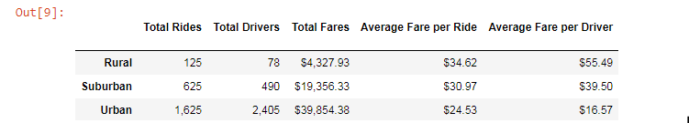

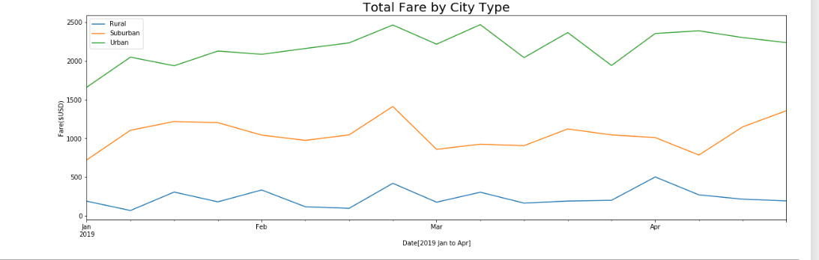

During the analysis, I encountered several challenges. One is that I need to search and learn how to use new codes and overcome errors in syntax. Another challenge would be some codes may not show right results and I need to figure out what is the reason or find other ways to get the right results. The best way to overcome the challenge is to search online to see examples and how others are using the code and what the code is using for the specific questions. It is also helpful that I look at previous activities and analysis to see if any old code I can use again and what is the right way to write the codes. Asking classmate and teachers’ help is also useful.

Based on the analysis, it is reasonable that we have the highest level of drivers in urban area. But it may increase revenue if we assign more drivers in rural and suburban areas because their average fare per ride and per driver are all higher than urban areas and some more drivers would increase revenue. In addition, I suggest to get analysis for fares per mileage per city type to see that if higher average per rides and drivers for rural area is due to higher mileage or higher fare per mileage. I also suggest to extend the time period of the fares analysis so that we see how seasons would affect fares. For the fares per mileage analysis, we would need to get mileage information for each ride. Then the fares would be divided by mileage to get fares per mileage for each ride. And then we can get the mean, medium and mode for fares per mileage for each city type and use plot chart to see the level of fares per mileage. For the seasoning analysis, we can extend the period from Jan to April 2019 to Jan to Dec 2019 and use plot chart to see if seasons would affect fares level.